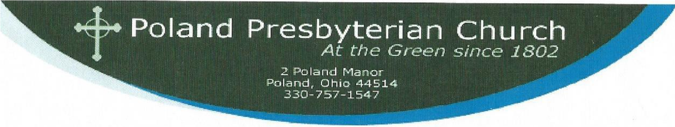
August 24, 2014
21st Sunday in Ordinary Time
Romans 12:1-8 The Rev. Robbin Del Nagro
“Be Transformed”
The church is a non-conformist community. If we are not distinguishable from the society around us then we have failed to understand Paul’s message in this text. What is the difference between a church that seems fresh, vital, and alive and one that seems close to its expiration date? Paul seems to indicate that it depends on for what we are willing to sacrifice ourselves. Self sacrifice is not a concept we are unfamiliar with. We do it for all kinds of seemingly good reasons. We sacrifice our money to put our children through college, to fund our retirement accounts, to buy a home. We sacrifice our time to nurture our children or visit our grandchildren, to work overtime, or to give service to the community. We sacrifice our labors to make plant a garden or give a dinner party.
If you have an expensive hobby you must sacrifice something in order to enjoy it. I used to love to fly a small plane. But when I was called to serve the church I had to sell that expensive toy. That was one of the implications of living into my own self sacrifice, a sacrifice of identity and of the way that I chose to use my gifts. It was the implication of choosing one good over another. When I had an airplane it was easy for me to refer to my self identity as a pilot. Of course I was also a Christian was there was a difference in priorities. It is easier or us to think of ourselves more highly if we have a unique identity than if we are simply one more of the millions of Christians in the world.
But as one of many we all contribute and no one gift is ranked higher than another. I might be the pastor but without ushers or acolytes or Patti or Tammy or Ray or Brian, or Erika, or any of you, I can’t really do much. We all have different jobs in the church, even if it is to pray for others or to receive the gift of others’ care of us. No one of us in unimportant and not one of us is more important, no matter how much we do or how much we give or how much we sacrifice.
It’s not easy to transform our attitudes to think this way. We have, most of us, spent a lifetime sacrificing so that we can be special in some way and highly thought of. Now we are being called to let go of thinking we are special and just be one of the crowd. “Renew your mind”, Paul tells the Romans. Think in new ways. Make your whole life an expression of devotion to God. Don’t give your sacrifices in vain. Don’t sacrifice for idols. Sacrifice for the one who made you and loves you walks with you each day.
The transformation that marks a fresh and renewed church is a gift of pure grace. But here is what it looks like when we have been touched by the Holy Spirit and are moving with the spirit through transformation. First, we change individually. We begin to see that we need continued participation in our faith community and that through that participation we are individually growing stronger. We enjoy being here! Individually we practice things like prayer and meditation, Bible study, book study, and participation in mission projects and caring ministries. We worship regularly and with our whole body and soul. We practice sacrificial giving of both our time and our resources. Then, individually we find that we are more than individuals. We are part of a vibrant and sacred community.
Yesterday the session was on retreat the the Villa Maria retreat center. I was moved by the story told us in our orientation by Matt, the program director. The community of the Humility of Mary sisters who founded the center came here from France in 1864; 11 sisters and four orphans. Their ministry was to orphans and they supported themselves by farming. This was difficult work and the sisters petitioned their bishop after a bit to let them return to France. He would not grant their request and they had to stay and overcome the hardships. Through the years their ministry changed and they opened a girl's boardig school. Later that school closed and their ministry changed to retreat ministry. I was also moved to know that one of the sisters feels her ministry is to pray for others. I imagine she is older and perhaps in failing health. She prays for each group that comes there. He didn't tell us her name, but I found it astonishing to think of this Catholic sister praying all week long for our Presbyterian Church, our session, and our retreat. She is part of a vibrant and sacred community. And our community can be vibrant and sacred in our own way as well.
Do not be conformed to this world. Paul recognized that the goodies of this world will always hold temptation for us. It is tempting to focus on those goodies. But these goodies will always leave us wanting, searching for more, ultimately empty inside. What we love most we will sacrifice for.
When I sold medical products I worked for the rewards of the material world. In the church the rewards of our work are very different. They are less tangible than a pay check but no less real. The church begins to embody our lives and we begin to become embodied in the church. No longer are we the “frozen chosen” but we are on the move. We walk forward to read scripture or receive communion, we move around in our pews to greet those in back of us or in another row. We use our bodies to move whatever needs to be moved, to embrace one another, to converse and laugh together. We raise our voices with emotions and gusto. We use our bodies to show our love and gratitude to God for one another. This is our sacrifice to God. This is our spiritual worship! And it is important!
Worship happens on Sundays but it doesn’t end when we leave this place. Our spiritual worship continues throughout the week, in our homes and in our workplace - in our gardens and with our friends. We might not think of it as worship or call it that, but that is what it is when we are acting in concert with the will of God - living our lives doing what is good and acceptable to God - renewing our spirits and transforming our minds to think in new and exciting ways about the world we live in.
A transformed and renewed mind sees the world as good. It sees the good in others. It sees God in all of nature - in children and animals and flowers. A renewed mind is open, not closed. It is able to hold different thoughts about the nature of God and the life of Jesus without feeling threatened or afraid. A transformed spirit and a renewed mind trust that Christ walks with us to open our eyes to what is right and good and to help us make wise choices, and to properly order our priorities.
Transformation is simply recognizing that we have all been given gifts of grace. It is catching hold of a vision larger than ourselves and finding our place in that vision. Where is your strength? Find it, hold firm to it, grow into it, and use it for the building up of this body of Christ. Be passionate. For this is your spiritual sacrifice and your worship.

